**Experiment-1.5**

**Student Name: Milan Sharma UID: 23MAI10003**

**Branch: CSE AIML Section/Group: 23MAI-1**

**Semester: 02 Date of Performance: 29/02/24**

**Subject Name: Research & IPR Lab Subject Code: 23CSP-667**

Aim of the Experiment:

Write an article on topics given below

a) What is an Industrial Design.

b) Who can apply for Industrial Design.

c) What are the essentials for the registration of design.

d) What is duration of Industrial design.

e) Flow chart of design application procedure

**Technical Article:**

**Q1.** What is an Industrial Design?

Sol. -

Industrial design is a discipline that focuses on the aesthetic and functional aspects of products and systems. It involves the creation and development of designs for mass-produced items, considering factors such as form, usability, ergonomics, manufacturing processes, and user experience. Industrial designers aim to improve the overall design, appearance, and functionality of products, making them more appealing, efficient, and user-friendly.

Key aspects of industrial design include:

1. Form and Aesthetics: Industrial designers work on the visual aspects of products, ensuring they are aesthetically pleasing and align with the brand or intended market.
2. Functionality and Usability: Designers prioritize the usability of products, making them intuitive and user-friendly. They consider how people interact with and use the products in their daily lives.
3. Materials and Manufacturing Processes: Industrial designers need to have knowledge of various materials and manufacturing techniques to ensure that the designed products can be produced efficiently and cost-effectively.
4. Ergonomics: Designers consider the human factor, ensuring that products are comfortable and safe to use. This involves understanding human anatomy, physiology, and psychology.
5. Market and User Research: Industrial designers often conduct research to understand market trends, user preferences, and the needs of the target audience. This information helps in creating products that meet consumer demands.
6. Prototyping and Testing: Before mass production, industrial designers often create prototypes to test the functionality and design of the product. This iterative process helps in refining the design based on feedback and testing results.
7. Sustainability: With a growing emphasis on environmental consciousness, industrial designers are increasingly incorporating sustainable practices into their designs, considering the life cycle of products and the environmental impact of manufacturing processes.

Industrial designers may work in various industries, including consumer electronics, furniture, automotive, medical devices, and more. Their goal is to enhance the overall user experience while meeting the practical and commercial requirements of the products they design.

**Q2.** Who can apply for Industrial Design.

Sol.-

Individuals with a passion for design, creativity, and problem-solving often pursue a career in industrial design. The field is diverse, and people from various educational backgrounds can enter industrial design. Here are some paths that individuals may take to apply for industrial design:

1. Industrial Design Degree: Many industrial designers hold a bachelor's or master's degree in industrial design, product design, or a related field. These programs provide a comprehensive education in design principles, materials, manufacturing processes, and user-centered design.
2. Engineering or Architecture Background: Individuals with degrees in engineering or architecture might also transition into industrial design. The technical knowledge gained in these fields can complement the design skills necessary for industrial design.
3. Art and Design Degrees: Those with degrees in fine arts, graphic design, or other design-related disciplines can pursue a career in industrial design. They may need to supplement their education with courses or experiences specific to industrial design.
4. Self-Taught Designers: Some successful industrial designers are self-taught and have developed their skills through hands-on experience, personal projects, and continuous learning. Building a strong portfolio is crucial for self-taught designers to showcase their abilities.
5. Cross-Disciplinary Backgrounds: Industrial design benefits from a diverse range of perspectives. Individuals with backgrounds in psychology, anthropology, marketing, or business may find opportunities in industrial design, especially if they can contribute insights into user behavior and market trends.
6. Portfolio and Experience: Regardless of educational background, a strong portfolio showcasing design projects, creativity, and problem-solving skills is essential. Real-world experience through internships, freelance work, or personal projects can significantly enhance an individual's chances in the field.
7. Continuous Learning: Industrial design is an ever-evolving field, and staying updated with the latest design trends, technologies, and materials is crucial. Taking workshops, attending conferences, and participating in design competitions can contribute to ongoing professional development.

Aspiring industrial designers should research educational programs, build a portfolio, and gain practical experience to increase their chances of success in the competitive job market. Networking within the design community and seeking mentorship can also be valuable for career growth in industrial design.

**Q3.** What are the essentials for the registration of design.

Sol.-

The registration of a design typically involves a legal process to protect the visual aspects of a product or article. The specifics of design registration can vary by country, as different jurisdictions have their own regulations and requirements. However, here are some general essentials for the registration of a design:

Novelty and Originality:

The design must be new and original, meaning it has not been disclosed to the public before the filing date of the application. Designs that are widely known or used are generally not eligible for registration.

Industrial Applicability:

The design should be capable of being produced by an industrial process. This criterion ensures that the design is applicable to mass production and not limited to a unique or one-of-a-kind item.

Distinctiveness:

The design should possess a level of distinctiveness or uniqueness that sets it apart from existing designs. It should not be a common or generic shape or configuration.

Application Form:

Submitting a completed application form is a fundamental step. This form typically includes details about the applicant, a description of the design, and representations (drawings, photographs, or other visual representations) of the design.

Drawings or Representations:

Clear and accurate drawings or representations of the design are crucial for the application. These visuals should clearly depict the features for which protection is sought.

Priority Claim (if applicable):

In some cases, applicants may claim priority based on an earlier application filed in another country. This can be important for securing protection in multiple jurisdictions.

Filing Fees:

Payment of the required filing fees is a standard part of the registration process. The fees may vary depending on the jurisdiction and the type of application.

Examination Process:

The design may go through an examination process to ensure it meets the legal requirements for registration. This may involve assessing novelty, originality, and compliance with design regulations.

Duration and Renewal:

Design registrations are typically granted for a specific duration. In many cases, they can be renewed upon payment of renewal fees, allowing the design protection to be extended.

Documentation of Priority:

If claiming priority based on an earlier application, proper documentation supporting the priority claim should be provided.

Power of Attorney (if required):

Some jurisdictions may require a power of attorney to be submitted along with the application. This document authorizes a representative to act on behalf of the applicant.

It's important to note that the specifics can vary, so individuals or businesses seeking design registration should consult the intellectual property office or authority in the relevant jurisdiction for detailed and up-to-date information on the requirements and procedures.

**Q4.** What is duration of Industrial design?

Sol. -

The duration of industrial design protection varies from country to country, and it is typically specified by the intellectual property laws of each jurisdiction. In general, industrial design protection is granted for a limited period, after which the design may enter the public domain. The duration of protection is intended to balance the interests of designers and creators with the public interest in having access to new and innovative designs.

Here are some common scenarios for the duration of industrial design protection:

United States:

In the United States, industrial design patents have a duration of 15 years from the date of grant. This duration was established under the Design Patent Act of 1842.

European Union:

In the European Union, registered Community designs, which cover the entire EU, are initially granted protection for five years and can be renewed in five-year increments, up to a maximum of 25 years.

Canada:

In Canada, industrial design registration provides protection for an initial term of 10 years from the registration date. No renewal is possible.

United Kingdom:

In the United Kingdom, registered designs are granted an initial term of 5 years, which can be renewed for additional periods up to a maximum of 25 years.

Australia:

In Australia, registered designs have an initial term of five years, with the possibility of renewal for up to a total of 10 years. It's important to note that the renewal process, if applicable, usually involves the payment of additional fees. Additionally, some countries provide shorter-term protection for certain types of designs, such as those related to spare parts for complex products.

Design owners should be aware of the specific rules and regulations in the jurisdictions where they seek protection, and they may need to monitor and manage the renewal process to maintain their design rights for the maximum allowable duration.

**Q5.** Flow chart of design application procedure

Sol. –

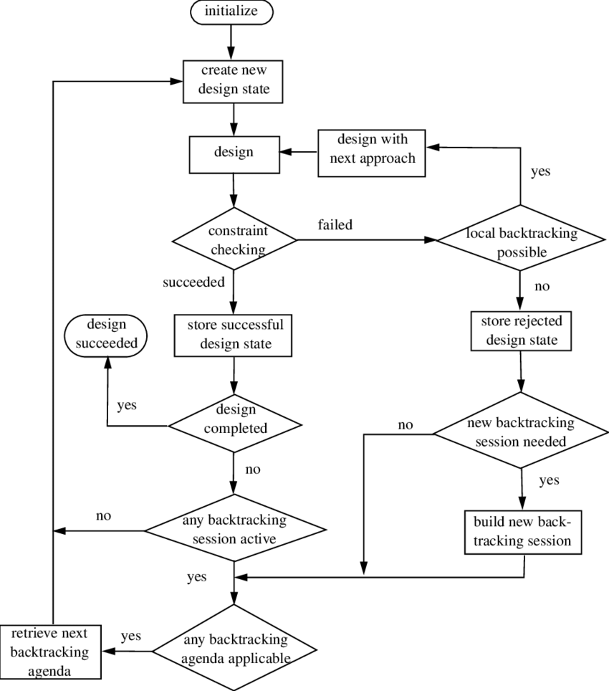

**Viva questions and answers (very short type):**

Q: What is the primary focus of industrial design?

Industrial design primarily focuses on improving the aesthetic and functional aspects of mass-produced products.

Q: Why is usability important in industrial design?

Usability is crucial in industrial design to ensure that products are user-friendly, intuitive, and meet the practical needs of consumers.

Q: How long is industrial design protection typically granted in the United States?

Industrial design protection in the United States is granted for 15 years from the date of grant.

Q: What role does sustainability play in industrial design?

Sustainability is increasingly important in industrial design, guiding the use of eco-friendly materials and processes to minimize environmental impact.

Q: Can individuals from diverse educational backgrounds pursue a career in industrial design?

Yes, individuals from various backgrounds, including engineering, art, and business, can enter the field of industrial design.

**Learning Outcomes:**

1. Learned about Industrial Design and its process etc.
2. Learned about function and uses of Designs.
3. Learned how to get our own Design and process related to it.
4. Learned about the duration of different types of Industrial Design.